Vol.4 Issue 1

**Editors Message**

Welcome to another issue of GNDEC Times. We have not been able to bring out the issue for quite some time now due to certain administrative reasons. We now assure you that you shall be receiving the issue regularly. Some changes have been suggested by senior faculty members regarding the publication. We are working on the suggestions and shall try our best to incorporate these in coming issues. A team of students is being prepared to assist the editorial board. Some new columns shall be added to pep up the outlook of this newsletter. We welcome your valuable comments and suggestions which may be mailed to [colmag@gndec.ac.in](mailto:colmag@gndec.ac.in).

Happy Reading

Editor

**Director’s Message**

It is matter of great satisfaction that new improved issue of GNDEC Times is being published after a gap of sometime. I do hope that the editorial team will now be more regular in bringing out further issues. I have pleasure to report that inspite of the deep recession and dwindling admission intake at various colleges, we have still managed to fill all seats in all streams. This further indicates the faith the society has in our college. It also adds to the burden of expectations the society has from us. The NBA and NAAC teams for accreditation inspection are due any moment now. I appeal to all members of GNDEC family to gear up for arduous task ahead. Wishing you all good luck.

Director

**College news**

It is matter of pride for all GENCONIANS that five of our alumnus have been promoted as Chief Engineers by Punjab State Power Corporation Ltd.:

i) Er. Rakesh Kumar Sharma

ii) Er. Arun Kumar Gupta

iii) Er. Karamjit Singh Khera

iv) Er. Karnail Singh Mann

v) Er. Jarnail Singh

Heartiest Congratulations from GNDEC Family. Guru Nanak Dev Engineering College, being their Alma Mater is proud of its Alumni. This marvelous achievement will really play an unparalleled and impeccable role in encouraging other budding engineers of this institution to touch the new heights by way of hard work, devotion and zeal towards their work.

It is matter of great pleasure that renowned Magazine OUTLOOK (Monthly Magazine July, 2014 Edition) has ranked GNDEC, Ludhiana on 37th position in the ranking of Top 75 Engineering colleges of Nation and First among Engineering Colleges of Punjab.

The 68th Independence Day was celebrated in the Guru Nanak Dev Engineering College, Ludhiana with full zeal and zest. The Director of the college Dr. Manohar Singh Saini hoisted the Tricolour and congratulated the staff & students. On this occasion Deans, HODs, staff and students from various departments of the college along with their families were present. The parade was performed by the NCC cadets of the College. After the concluding ceremony sweets were distributed among all present.

**CIVIL ENGINEERING DEPARTMENT**

Dr. J.N. Jha , HOD (Civil) delivered the Keynote address on “Earthquake hazards, causes and mitigation” at National Conference” Innovations in engineering, pharmaceuticals and management sciences” on May 30,2014 at Rayat Behra University

The department organized an expert lecture on “Concrete Revolution – 7000 BC to 2014 AD” on Aug. 20, 2014 by Sh. Umesh Soni from Ambuja Cements Ltd.

**Publications of department:**

1. Choudhary, A.K., J.N.Jha, K.S.Gill and S.K. Shukla "Utilization of fly ash and waste recycled product reinforced with plastic waste as construction material in flexible pavement" Geo-characterization and Modeling for sustainability, Geo-Congress 2014, ASCE, GSP 234,Georgia, USA.23-26 February, 2014, pp 3890-3902 [ISBN (print): 978-0-7844-1327-2]
2. Prashant Garg, Harvinder Singh, J.N.Jha " Design Chart for foundation system reinforced with peripheral vertical inserts" Ground Improvement and Geosynthetics, GSP 238, ASCE 2014, Geo- Sanghai 2014, Sanghai, China, 26-28, May, 2014 pp 20-29[ISBN (print): 978-0-7844-1340-1]
3. Gurdeepak Singh, Amandeep Singh, Charanjit Singh, Gurpuneet Singh “Erosion study of foot hills of Dhauladhar by uase of GPS and Total station” at National conference on "Innovations in Engineering and Information Technology" on March 28-29, 2014 at KCET, Amritsar

**New faculty members:**

Following faculty members joined the civil engineering department:

1. Prof. Jagpreet Singh
2. Prof Amanpreet Singh
3. Prof.Rupinder Singh Litt
4. Prof Lakhvir Kaur
5. Prof. Heena Malhotra
6. Prof. Ivjot Singh

GNDEC welcomes new members to the family.

**ELECTRICAL ENGINEERING DEPARTMENT**

The faculty of Electrical Engineering presented following technical papers:

1. Dhingra Arvind, Sharma Ashwani Kumar, Power Quality: Monitoring & Measurement, International Conference in Electrical Engineering, Power Control, Electronics and Communication Technology (EEPCECT-2014) organized by Krishi Sanskriti, JNU, New Delhi, 31st May-1st June, 2014.
2. Dhingra Arvind & Others, Simulation & Analysis of Grid Connected Solar Photovoltaic system, National Conference: Recent Advances in Power Systems, RAPS14, PEC University of Technology, Chandigarh, June 28, 2014, pp 305-312, ISBN 978-9383842599
3. Dhingra Arvind & Others, Design & Feasibility of combined biomass and solar power plant for generation of electric power, National Conference: Recent Advances in Power Systems, RAPS14, PEC University of Technology, Chandigarh, June 28, 2014, pp50-57, ISBN 978-9383842599
4. Dhingra Arvind & Others, Design & Feasibility of Micro hybrid solar biogas plant, National Conference: Recent Advances in Power Systems, RAPS14, PEC University of Technology, Chandigarh, June 28, 2014, pp 75-82, ISBN 978-9383842599
5. Dhingra Arvind, Kumar Ashwani, Power Quality Issues: Monitoring & Measurement, International Journal of Electronic and Electrical Engineering, Vol.7, No.10, 2014, ISSN 0974-2174, pp 1049-1056

STTPs/FDPs attended

The Faculty of the department attended the following STTPs/FDPs:

1. Two weeks AICTE sponsored Faculty Development Program on Advanced VLSI design techniques, GNDEC, Ludhiana, January 20th -31st,2014 attended by Er. Navneet Singh Bhangu, Er.Gagandeep Singh Sodhi, Er.Arvind Dhingra, Er.Harmeet Singh, Er.Sukhdeep Singh Boparai.
2. Two days workshop on NBA accreditation by Dr.A.Koteshwara Rao at GNDEC, Ludhiana, March 7-8,2014 was attended by Er.Jaswinder Singh, Dr.Y.S.Brar, Er.Khushdeep Singh, Er.Preetinder Singh, Er.Rupinderjit Singh, Dr.Kanwardeep Singh & Er.Arvind Dhingra
3. NPIU organized STTP on Right to Information act & Modern Day ICT at Kanyakumari, March 10th -14th, 2014 was attended by Er.Arvind Dhingra
4. Two days IEI & LCET organized Technical Symposium on Awareness of Non Conventional energy Resources, LCET, Katani Kalan, June 26-27, 2014 was attended by Er.Arvind Dhingra

Expert Lectures delivered:

1. To faculty members of RIMT Engg College, Mandgobindgarh on Marketing strategies for small businesses under FDP organized by NITCON under GOI scheme by Er. Arvind Dhingra
2. To faculty members of Gulzar Group of Institutes, Khanna on Total Quality Management in higher education by Er.Arvind Dhingra
3. During STEP organized Entrepreneurship development program on Entrepreneurship at LCET, Katani Kalan by Er.Arvind Dhingra
4. During two day symposium on Awareness of Non Conventional resources of energy at LCET, Katani Kalan by Er. Arvind Dhingra & Dr. Y.S.Brar
5. The keynote address during the National Conference on Electrical Engineering at IET, Bhaddal was delivered by Dr.Y.S.Brar
6. Dr.Kanwardeep Singh delivered an expert lecture at IET, Bhaddal

**ELECTRONICS & COMMUNICATIONS ENGINEERING DEPARTMENT**

The department of Electronic and Communication Engineering conducted TEQIP-II sponsored faculty development programme “Nature Inspired Computational Techniques for Engineering and Sciences” from July 21, 2014 to July 25, 2014. Dr. Amod Kumar, Director CSIO Chandigarh inaugurated the function. Dr. M.S. Saini, Director, GNDEC appreciated the efforts of ECE department for organizing this course. The resource persons from different reputed institutions like IIT Roorkee, IIT Ropar, DCRUST, Murthal etc. enlightened the participants with their expert views. Dr. J.N. Jha, Coordinator TEQIP GNDEC, Ludhiana graced the Valedictory functions as a chief guest. The course was coordinated by Dr. Sandeep Singh Gill, Dr. Munish Rattan and Pf. Narwant Singh Grewal.

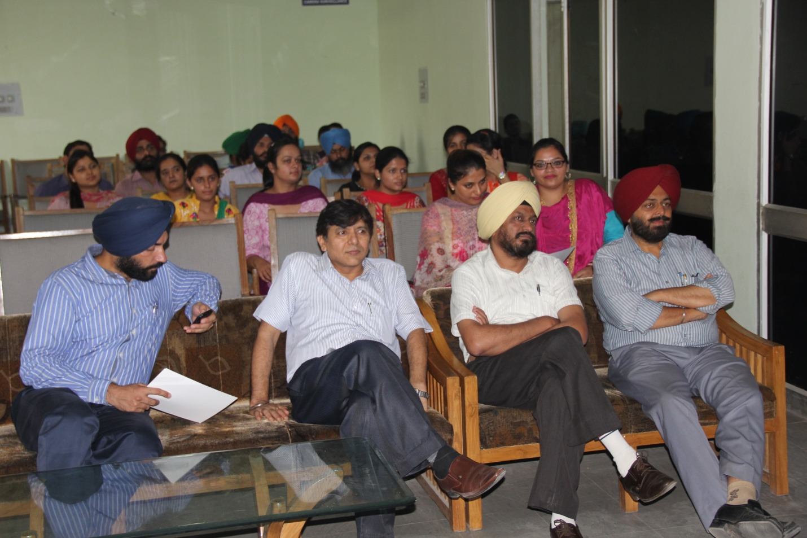 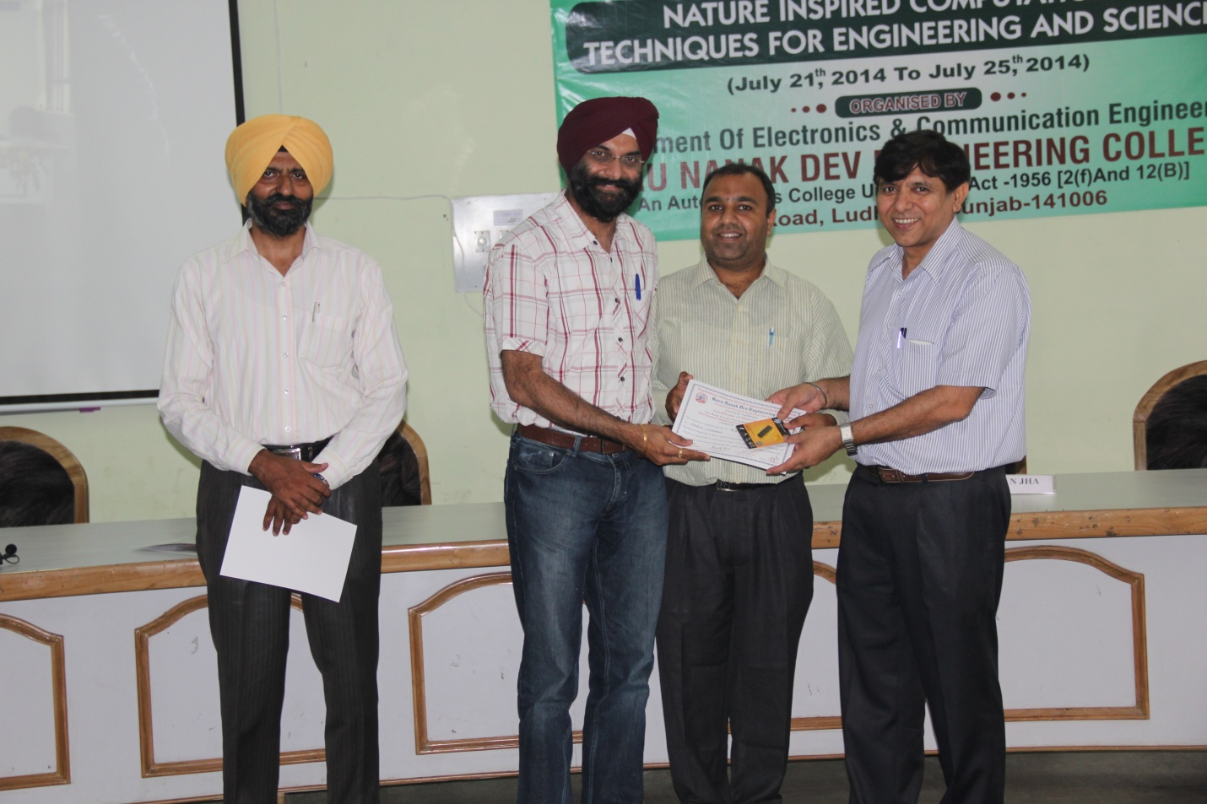

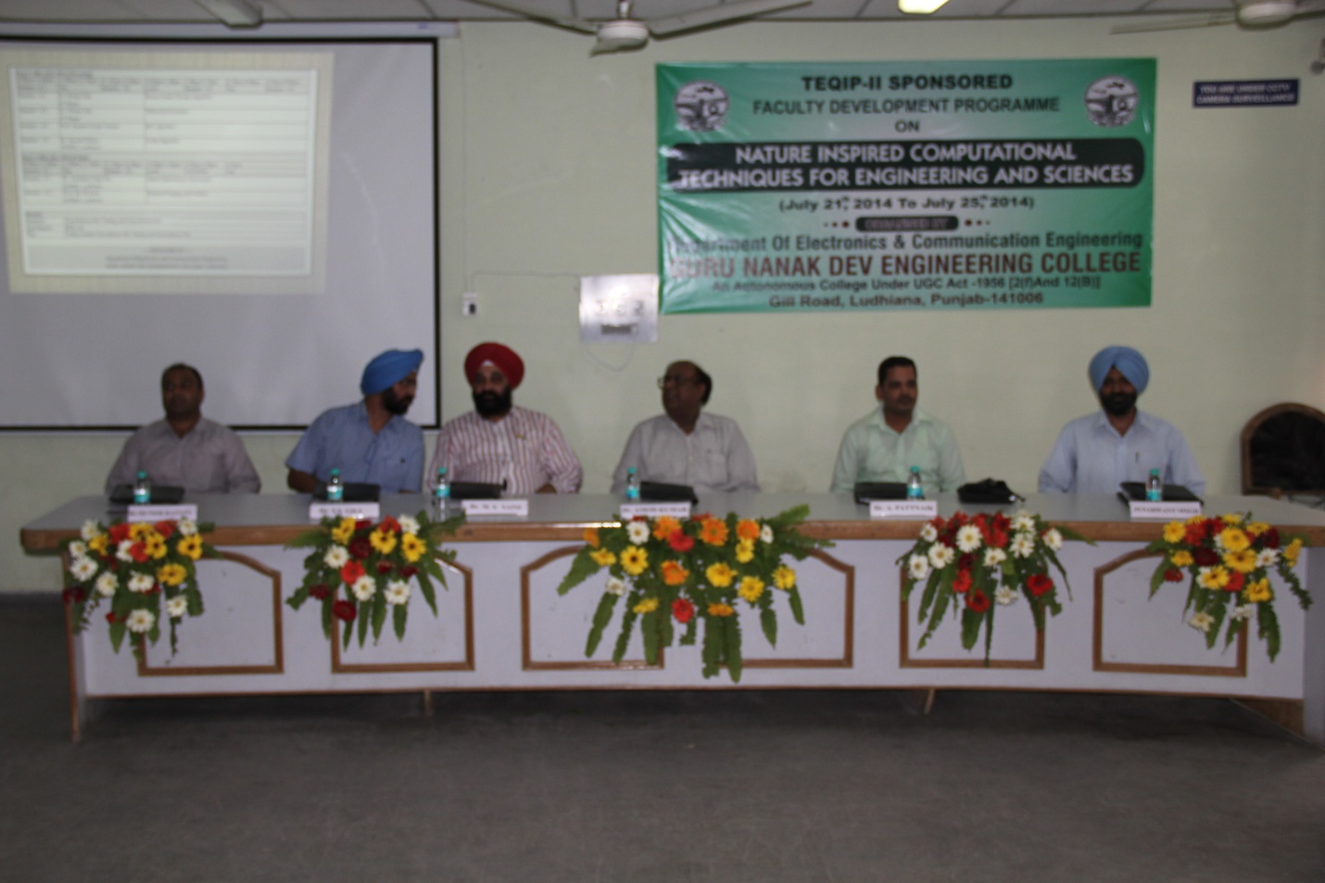

An expert talk cum workshop on “Swasthya slate” was organised by IETE student forum, ECE department in Guru Nanak Dev Engineering College on Sept 1, 2014. Dr. Kanav Kahol, Director, Public health foundation India, New Delhi (Alumni, ECE deptt., GNDEC) gave an expert lecture over this topic.

Swasthya Slate (developed by the Affordable Technologies Team at the Public Health Foundation of India led by Dr Kanav Kahol) is a bluetooth-enabled integrated diagnostic kit that works with an android based mobile system, to perform 33 diagnostics tests, and is equipped with various applications that are created strategically to increase access to health care and health education in the country.

Dr. M. S. Saini, Director, GNDEC Ludhiana appreciated the efforts of IETE student forum in organising such activities. The guest was honoured by worthy Director and Dr. S. S. Gill (H.O.D, ECE Deptt. and Coordinator, IETE Student Forum).

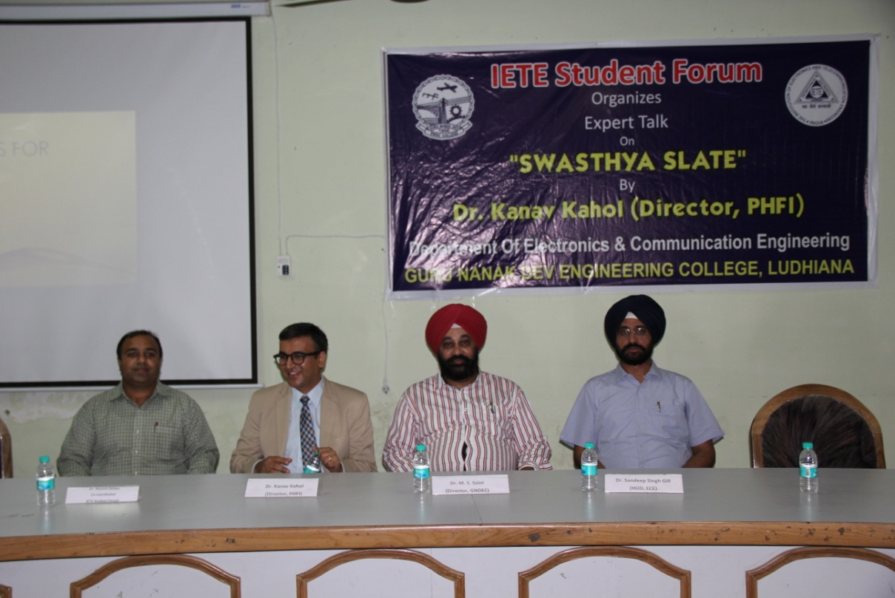

**Sitting from L to R:** Dr. Munish Rattan (Co-cordinator IETE Student Forum), Dr. Kanav Kahol (Director, Public health foundation India), Dr. M. S. Saini, (Director, GNDEC Ludhiana), Dr. S. S. Gill (H.O.D, ECE Deptt. and Coordinator, IETE Student Forum).

**Mechanical Engineering Department**

The following Expert Lectures Delivered in FDP/STTP by faculty members:

1. **Dr.Sehijpal Singh**
2. Flexible Surface Finishing Technologies, PEC University of Technology Chandigarh, 6th June 2014
3. Micro- finishing processes, Beant College of Engg and Technology Gurdaspur, 24th June 2014
4. Latest developments Abrasive machining, Delhi Technological university Delhi, 18th July 2014
5. Non conventional processes and technologies for micro/nano material removal, GNDEC, 29th July 2014
6. **Dr. Harwinder Singh**.
7. Recent Advances in Industrial Engineering, NIT, Jalandhar, July 08, 2013
8. Numerical & Computational Techniques in Engineering, Amritsar College of Engineering & Technology, Amritsar, July 11, 2013
9. Statistical Research Methods (Testing of Hypotheses and ANOVA), Guru Nanak College, Sukhchainana Sahib, Phagwara, October 21, 2013.

The faculty of the department published the following technical papers:

1. Singh Sehijpal, Dhawan, V., and Singh, I., “Prediction of Delamination Factor In Drilling Glass Fiber Reinforced Epoxy Plastics Using Neural Networks,” International Journal of Research in Engineering and Applied Sciences, 2, pp. 155-168, 2013
2. Singh Sehijpal, Dhawan, V., Singh, I., “Predictive Modeling of Delamination, Thrust Force and Torque in Drilling of GFRP using ANFIS,” International Journal of Advanced Manufacturing Systems, 4(1), pp. 1-15, 2013
3. Singh Sehijpal , Kumar H., Kumar P. Surface Finishing and Modification of Brass Tube by Magnetically Assisted Cold Worked Stainless Steel Pins   
   Journal of Tribology and Surface Engineering, Volume 3 Issue 3-4
4. Singh Sehijpal, Dhawan, V., and Singh, I, “Effect of Natural Fillers on Mechanical Properties of GFRP Composites, Journal of Composites, Volume 2013 (2013), Article ID 792620
5. Singh, H. and Kakkar, R. “Hybrid methodology for measuring the utilization of advanced manufacturing technologies using AHP and TOPSIS” Benchmarking: An International Journal, Vol. 20, No. 2, 2013. pp. 169-185.
6. Singh, H. and Singh, A. “Application of lean manufacturing using value stream mapping in an auto-parts manufacturing unit” Journal of Advances in Management Research, Vol. 10, No. 1, 2013. Pp. 72-84.
7. Singh, H. and Khamba, J.S. “A case study of Indian manufacturing organisation for utilisation of advanced manufacturing technologies” International Journal of Indian Culture and Business Management, Vol. 7, No. 2, 2013 pp. 226-239.
8. Sadioura, A.S., Singh, R. and Singh, H. “Machinability Index Evaluation: A Case Study of Carbide Inserts” Applied Mechanics and Materials, Vol. 330, 2013 pp. 86-90.
9. Singh, H. and Bhanot, N. “Benchmarking the Performance Indicators of Indian Railway Container Business using Data Envelopment Analysis” Benchmarking: An International Journal, Vol. 21, No. 1, 2014 pp. 101-120.
10. Singh, J. and Singh, H. “Continuous Improvement Strategies: An Overview” The Icfai Journal of Operations Management, Vol.9, No.1, February 2013. Pp. 32-57.
11. Singh, J. and Singh, H “Level of Usage of Continuous Improvement Strategies in SMEs of Northern India” Udyog Pragati Journal, Vol.37, No.4, October-December 2013 pp. 1-8.
12. Singh, H., Kumar, R. and Singh, J. “Evaluation of Thermal Power Plants of Punjab using Multi Attribute Decision Making (MADM) Approach” Proceedings of 3rd International Conference on Production and Industrial Engineering CPIE-2013 held at NIT, Jalandhar on March 29-31, 2013 (ISBN: 978-81-920453-1-3). Published In CD form
13. Singh, J. and Singh, H. “Benefits achieved after successful implementation of Kaizen approach in SMEs of Northern India – An Empirical Study” Proceedings of 3rd International Conference on Production and Industrial Engineering CPIE-2013 held at NIT, Jalandhar on March 29-31, 2013 (ISBN: 978-81-920453-1-3). Published In CD form
14. Gurmeet Kaur, Daljinder Singh and Jasmaninder Singh Grewal,“Effects of Filler wire composition on joining properties of GTAW stainless steel 202”, in proceeding of the international conference on research and innovations in mechanical engineering (ICRIME 2013), 24-26 October, 2013 at Guru Nanak Dev Engineering College, Ludhiana.
15. J Pal., “Implementation of Quality Control Tools in an Automobile Organization to Reduce the Rejection of Casting Components” International Conference on Research and Innovations in Mechanical Engineering (ICRIME-2013),Guru Nanak Dev Engineering College Ludhiana, pp.613-622 Oct. 24th-26th,2013. DOI: 10.1007/978-81-322-1859-3_57, Springer India 2014.
16. Singh, H. and Kumar, R “Measuring the Utilization Index of Advanced Manufacturing Technologies: A Case Study.” Proceedings of IFAC Conference on Manufacturing Modelling, Management and Control held at Saint Petersburg, Russia from June 19, 2013 to June 21, 2013 pp. 933-938

The department was actively involved in dissemination of knowledge through conferences and FDPs. The following were organised:

1. International conference on research and innovations in mechanical engineering, 24-26th October 2013
2. Two weeks faculty development programmer on “Finite Element Method and its Application” sponsored by AICTE, New Delhi was organized from 31st, October to 13th November, 2013.
3. One week faculty development program on Micro/nano material removal and additive technologies in advanced manufacturing, 28th July to 1st august 2014

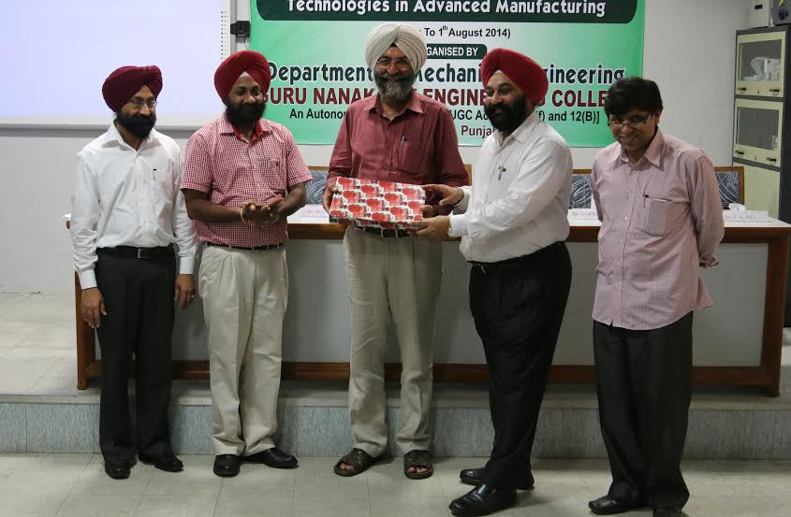

Pic: Dr.Buta Signh Dean Academic PTU, Kapurthala being welcomed by Dr.M.S.Saini, Director, GNDEC, Dr. Sehijpal Singh, HOD(Mechanical) & Dr.J.N.Jha, Co-ordinator TEQIP-II during the one week FDP on Micro/nano material removal and additive technologies in advanced manufacturing

Workshop/FDP/STP attended:

1. Dr. Sehijpal Singh attended a FDP on “Quality initiatives in higher education institutions” at ESCI Hyderabad
2. Prof. Deepinder Singh attended “International Workshop on Green and Sustainable Supply Chain Mechanism, Challenges and Research Opportunities” at ITM University Gurgaon on 16 July 2014.
3. Prof. Deepinder Singh, Prof. Prem Singh attended “Workshop on Computational Tools for Engineers” at GNDEC Ludhiana from 29 July 2013 to 03 August 2013.
4. Prof. Prem Singh attended one week faculty development programmer on “Recent Computing Paradigms” at GNDEC, Ludhiana from 7th to 11th July, 2014.
5. Dr. Harwinder Singh Attended two day workshop on Procurement Management Support System Training (TEQIP II) held at Guru Nanak Dev University, Amritsar from May 27-28, 2013.
6. Dr. Harwinder Singh attended ten days academic leadership program at Indian Institute of Management, Kozhikode from July30, 2013 to August 09, 2013
7. Dr. Harmeet Singh and Prof. Prem Singh attended one week short term course on “IC Engine Fuels and Combustion Technology” sponsored by MHRD, New Delhi at NIT, Jalandhar from 14th to 18th December, 2013.
8. Prof. Gurmit Kaur attended faculty Development Program on “finite Element Methods to solve engineering problems” organized by Department of Civil Engineering, Guru Nanak Dev Engineering College, Ludhiana from July 22 -26, 2013 at GNDEC, Ludhiana.
9. Prof. Gurmit Kaur attended Faculty Development Program on “Micro/Nano material removal and additive technologies in advanced manufacturing” organized by Department of Mechanical Engineering, Guru Nanak Dev Engineering College, Ludhiana from 28th july to 1st Aug. 2014 at GNDEC, Ludhiana.
10. Dr. Harwinder Singh Attended one week training program on Right to Information Act-2005 & Modern IT Practices by National Productivity Council, New Delhi held at Hotel Sparsa Resort, Kanyakumari from March 10-14, 2014.

Training of faculity:

1. Prof. Depender Singh attended training of NCC Officer Training programmer at Punjabi University, Patiala from 13 June 2013 to 19 June 2013.

Book published by faculty

1. JATINDER PAL, “Implementation of Quality control Tools to Reduce the Rejection of Casting Components” No.978-3-659-25758 Published by Lap Lambert Publishing Company Germany , 2013.
2. Bhanot, N., Singh, H. and Bhatti, R.S. (2014), “Benchmarking of Indian Rail Freight by DEA”, Encyclopedia of Business Analytics and Optimization (EBAO) published by IGI-Global USA (In-Press) (Book Chapter)

**M. Tech. Completed**:

a) Jaspreet Singh Asstt Professor has completed M. E. in manufacturing technology from NITTTR, Chandīgarh.

**SAE Activities:**

The students’ chapter of Society for Automotive Engineers remained actively involved in pursuit of excellence by participating in various events and bringing laurels to the institute.

1. SAE Northern India Section EFFICYCLE: Efficycle event was held at University Institute of engineering and Technology, Punjab University Chandigarh in the month of October and our team got 17th position in all over India.

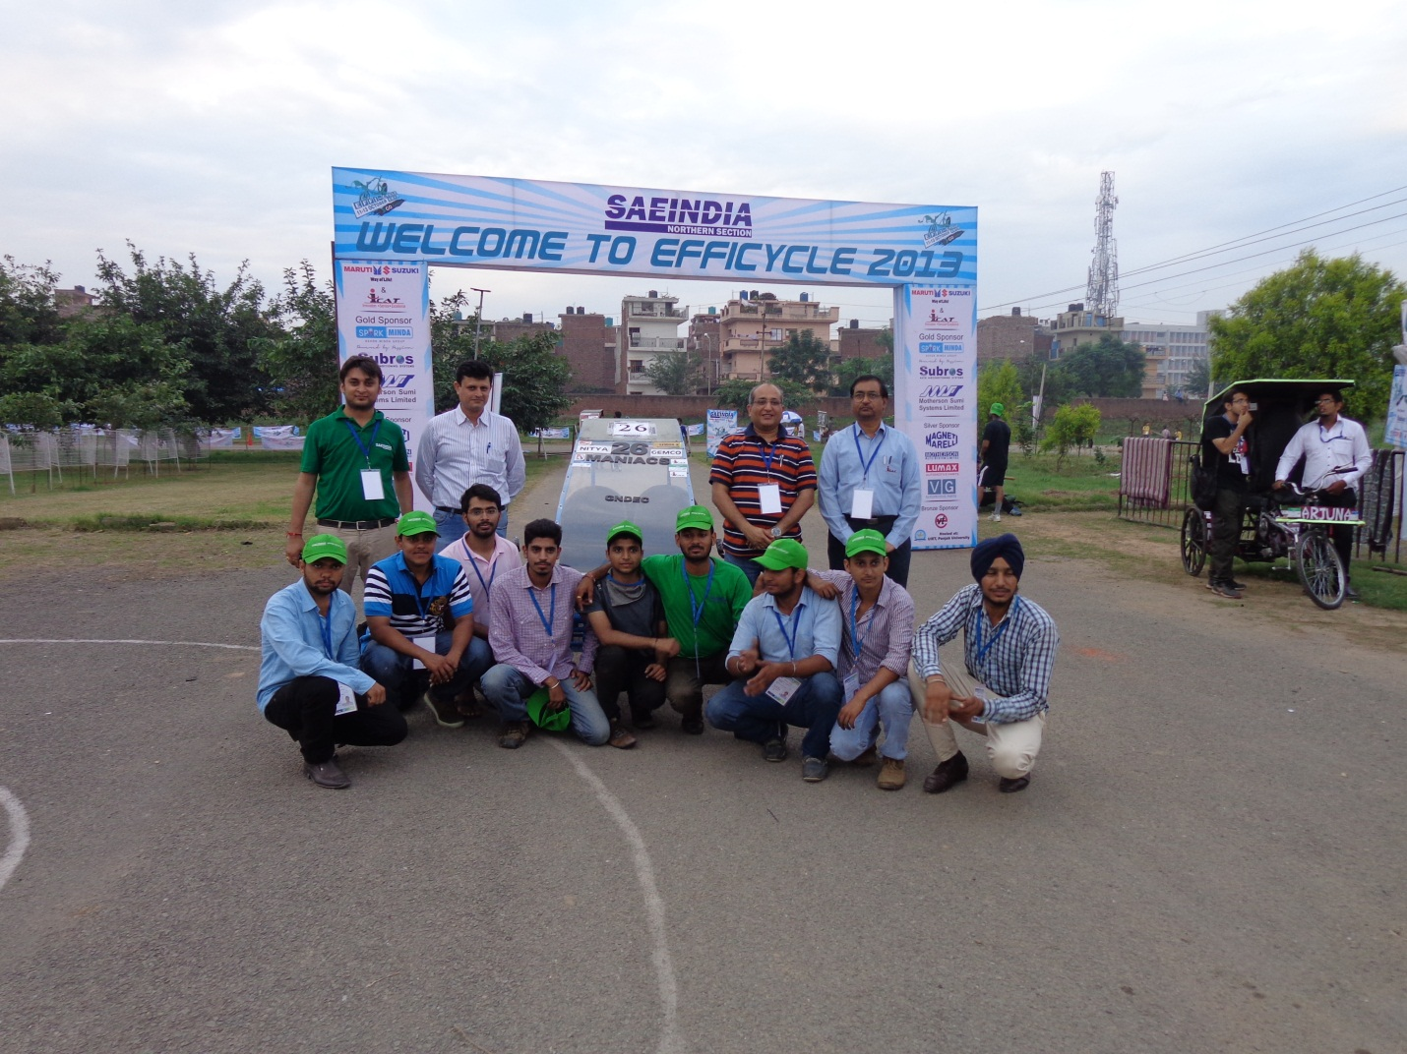

1. **International Cycle Expo 2014** was held at Govt. College for women Ludhiana on 28-30 March 2014, where Efficycle 2013 was displayed and one of our team members **PUNEET MADHAV** was placed an International company **Holland mechanics Yangzhou, China**.
2. BAJA SAE INDIA 2014 was held at Pithampura Indore NATRIP Testing Facility by ARAI Get 14th all India Rank and 6th in endurance round.

**MCA Department**

A “Seminar on Ethical Hacking and Personality Development” on 11/04/2014 in Testing and Consultancy Cell was organized by the department. It was attended by over 70 students. Dr.H.S.Rai, Dean, Testing and Consultancy cell, GNDEC and Prof. Nirmal Singh, Director, STEP, GNDEC, Ludhiana were the chief guest. The resource persons were:

Er.Amit Sharma, STEP GNDEC Ludhiana

Mrs.Sunita Sharma, STEP GNDEC Ludhiana

Prof. Puneet Singh, STEP GNDEC Ludhiana

A Technical Event “Infomania” organized by Department of Computer Applications On 25/02/2014. The event consisted of following rounds:

1. Abbrevation

2. Stretch it

3. What’s App Quiz

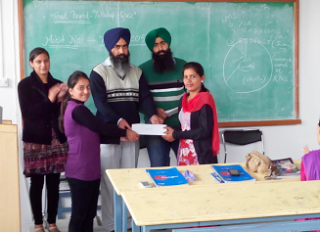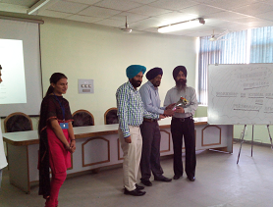

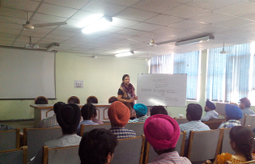

**SportS DEPARTMENT**

The sports department excelled and brought laurels to the college. The following were the achievements:

**ACHIEVEMENT IN PTU INTER-COLLEGE TOURNAMENTS**

Boys Girls

|  |  |  |  |
| --- | --- | --- | --- |
| Handball | First | Cross-country | First |
| Cross-country | First | Cycling | First |
| Chess | First | Handball | Second |
| Football | First | Hockey | Second |
| Best Physique | First | Lawn tennis | Second |
| N/S Kabaddi | Second |  |  |
| Lawn-tennis | Second |  |  |
| Cycling | Second |  |  |
| Swimming | Third |  |  |

**INTER-UNIVERSITY PARTICIPATION:**

The following students represented PTU, Jalandhar in North Zone/All India Inter-Varsity Tournaments:

**LAWN-TENNIS**

1. Ramanpreet Singh D4PE-104051 (**Captain**)
2. Gaurav Tripathi D4CE-100036

**CHESS**

1. Sukhwinder Singh D4CSE-105138

**BASKETBALL**

1. Ramandeep Kaur D4CSE-105158
2. Sonia Kumari D4CSE-105160

**WATERPOLO**

1. Simrandeep Singh Chahal D4ECE-103048
2. Pushpdeep Singh Chahal D1ME-131344

**CRICKET**

1. Himanshu Sharma M.Tech.-2nd yr (SE-1220) (**Captain)**

2. Kuljinder Singh D2I.T-126114

3. Ajayveer Singh Sidhu D3CE-110022

4. Ankit D2E.E-122008

**N/S KABADDI**

1. Surinder Kumar D4-ECE-100165
2. Kapil Kumar D4-ECE-103099
3. Arvind Pandey D4-CE-100165

**EXTRA_MURAL ACTIVITY: TOURNAMENT ORGANISED:**

1. PTU Inter-college Zonal Football Competition in Oct.’2013.
2. PTU Inter-college Swimming in Aug.’2013.

**INTRA_MURAL ACTIVITY: TOURNAMENT ORGANISED**

1. Inter-branch/year matches in Basketball, Football, Table tennis
2. B.Tech 1st year Cross-country Meet

**PTU Over all Trophies:-**

1. Over All Men Championship Trophy
2. Over All Women Championship Trophy
3. Over All Combined Men & Women Championship Trophy

**Boys** **Girls**

|  |  |  |  |
| --- | --- | --- | --- |
| Athletics | First | Athletics | First |
| Cross-country | First | Volleyball | First |

**INTER-UNIVERSITY PARTICIPATION:**

The following students represented PTU, Jalandhar in All India Inter-Varsity Tournaments:

**SHOOTING**

1. Gurleen Kaur D4CE-100154
2. Harsumeet Singh D1ME-1311597

**BEST PHYSIQUE**

1. Mehakdeep Singh Randhawa D3-ME-1311597
2. Amardeep Singh Anand D3CE-120004

3 Gaganpreet Singh D2.ME-121380

4 Vimal kishore Singh D3.EE-112085

**POWERLIFTING**

1. Sukhwinderpal Singh D4CE-100157

**EXTRA_MURAL ACTIVITY: TOURNAMENT ORGANISED:**

PTU Inter-college Zonal Cricket Tournament was organized in Feb.’2014.

**INTRA_MURAL ACTIVITY: TOURNAMENT ORGANISED**

1. College Annual Athletic Meet in Feb.2014
2. Inter-branch/year matches in Basketball, Football, Volleyball & Cricket in March & April 2014
3. GNE Open Chess Tournament in April 2014

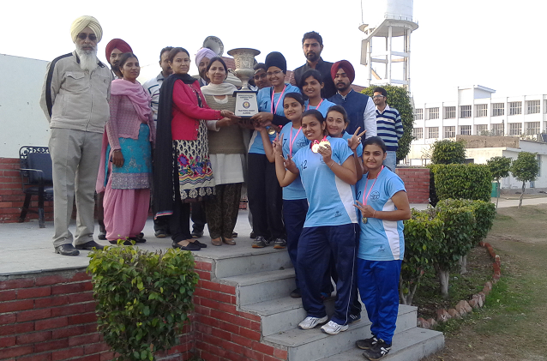 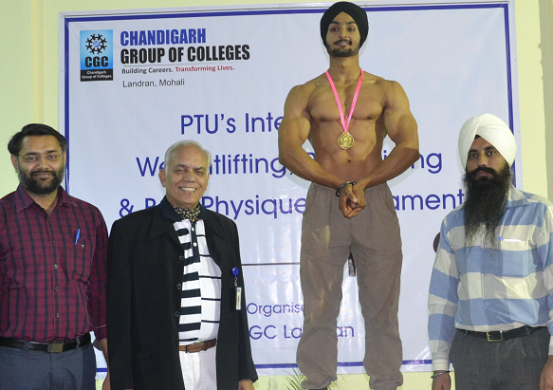

Girls Volleyball team First In PTU tournament Mehakdeep RandhawaPTU best Physique

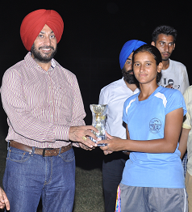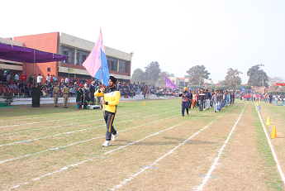

Gurpreet Kaur Sran PTU Best Cyclist March Annual Athletic Meet

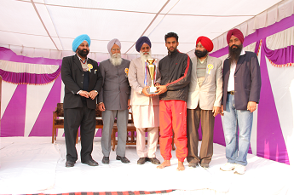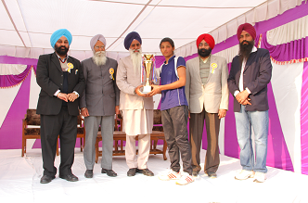

Best athlete (Boys) Sandeep Singh D3IT Best athlete (Girls) Mandeep Kaur D2IT

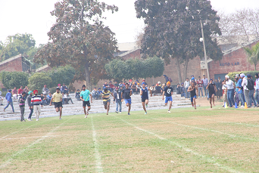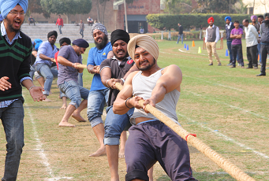

Athletes in action during annual sports meet